**M.ASHOK**

**192372107**

**DATE:07-06-2024**

**ASSIGNMENT - 2**

# 11. Container With Most Water

**You are given an integer array height of length n. There are n vertical lines drawn such that the two endpoints of the ith line are (i, 0) and (i, height[i]).**

**Find two lines that together with the x-axis form a container, such that the container contains the most water.**

**Return *the maximum amount of water a container can store*. Notice that you may not slant the container.**

**CODE:** def maxArea(A, Len) :

area = 0 for i in range(Len) :

for j in range(i + 1, Len) :

# Calculating the max area

area = max(area, min(A[j], A[i]) * (j - i)) return area

# Driver code

a = [ 1, 5, 4, 3 ] b = [ 3, 1, 2, 4, 5 ] len1 = len(a) print(maxArea(a, len1)) len2 = len(b) print(maxArea(b, len2))

OUTPUT:

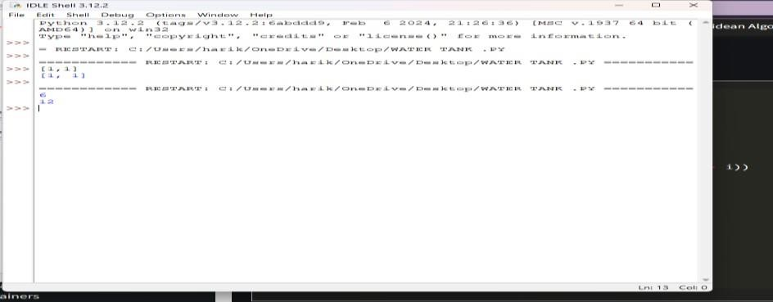

**12. Roman numerals are represented by seven different symbols: I, V, X, L, C, D and**

**M.**

**Symbol Value**

**I 1**

**V 5**

**X 10**

**L 50**

1. **100**
2. **500**

**M 1000**

**For example, 2 is written as II in Roman numeral, just two one's added together. 12 is written as**

**XII, which is simply X + II. The number 27 is written as XXVII, which is XX + V + II. Roman numerals are usually written largest to smallest from left to right. However, the numeral**

**for four is not IIII. Instead, the number four is written as IV. Because the one is before the five**

**we subtract it making four. The same principle applies to the number nine, which is written as**

**IX. There are six instances where subtraction is used:**

* **I can be placed before V (5) and X (10) to make 4 and 9.**
* **X can be placed before L (50) and C (100) to make 40 and 90.** ● **C can be placed before D (500) and M (1000) to make 400 and 900. Given an integer, convert it to a roman numeral.**

**CODE:** def value(r): if (r == 'I'): return 1 if (r == 'V'):

return 5 if (r == 'X'): return 10 if (r == 'L'): return 50 if (r == 'C'): return 100 if (r == 'D'): return 500 if (r == 'M'): return 1000 return -1 def romanToDecimal(str):

res = 0 i = 0 while (i < len(str)): # Getting value of symbol s[i] s1 = value(str[i]) if (i + 1 < len(str)): # Getting value of symbol s[i + 1] s2 = value(str[i + 1]) # Comparing both values if (s1 >= s2):

# Value of current symbol is greater # or equal to the next symbol res = res + s1

i = i + 1

else:

# Value of current symbol is greater # or equal to the next symbol res = res + s2 - s1 i = i + 2 else: res = res + s1 i = i + 1 return res

# Driver code print("Integer form of Roman Numeral is"), print(romanToDecimal("MCMIV")) OUTPUT:

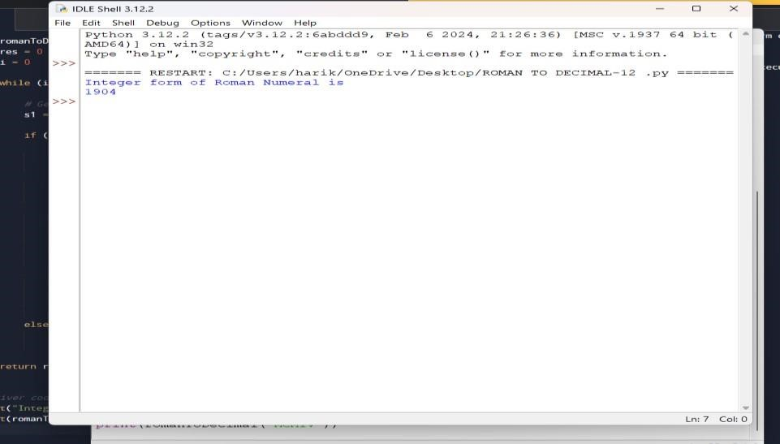

# 13. Roman to Integer

**Roman numerals are represented by seven different symbols: I, V, X, L, C, D and M.**

**Symbol Value**

**I 1**

**V 5**

**X 10**

**L 50**

1. **100**
2. **500**

**M 1000**

**For example, 2 is written as II in Roman numeral, just two ones added together. 12 is written as**

**XII, which is simply X + II. The number 27 is written as XXVII, which is XX + V + II. Roman numerals are usually written largest to smallest from left to right. However, the numeral**

**for four is not IIII. Instead, the number four is written as IV. Because the one is before the five**

**we subtract it making four. The same principle applies to the number nine, which is written as**

**IX. There are six instances where subtraction is used:**

* **I can be placed before V (5) and X (10) to make 4 and 9.**
* **X can be placed before L (50) and C (100) to make 40 and 90.**
* **C can be placed before D (500) and M (1000) to make 400 and 900.**

**Code:**

roman = {'I':1,'V':5,'X':10,'L':50,'C':100,'D':500,'M':1000} class Solution: def romanToInt(self, S: str) -> int:

summ= 0

for i in range(len(S)-1,-1,-1):

num = roman[S[i]] if 3*num < summ: summ = summ-num else:

summ = summ+num

return sum

OUTPUT:

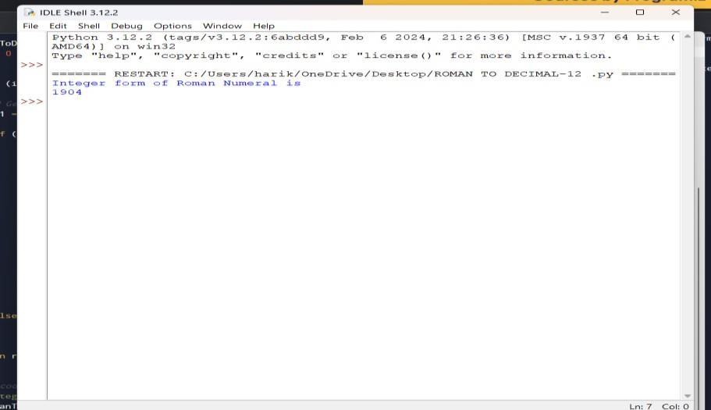

**14. Longest Common Prefix**

**Write a function to find the longest common prefix string amongst an array of strings. If there is no common prefix, return an empty string ""**

**CODE:** def longestCommonPrefix( a): size = len(a)

# if size is 0, return empty string if (size == 0):

return ""

if (size == 1): return a[0]

# sort the array of strings a.sort()

# find the minimum length from

# first and last string end = min(len(a[0]), len(a[size - 1])) # find the common prefix between

# the first and last string i = 0 while (i < end and a[0][i] == a[size - 1][i]): i += 1

pre = a[0][0: i] return pre

# Driver Code

if name == " main ":

input = ["geeksforgeeks", "geeks",

"geek", "geezer"]

print("The longest Common Prefix is :" , longestCommonPrefix(inp) OUTPUT:

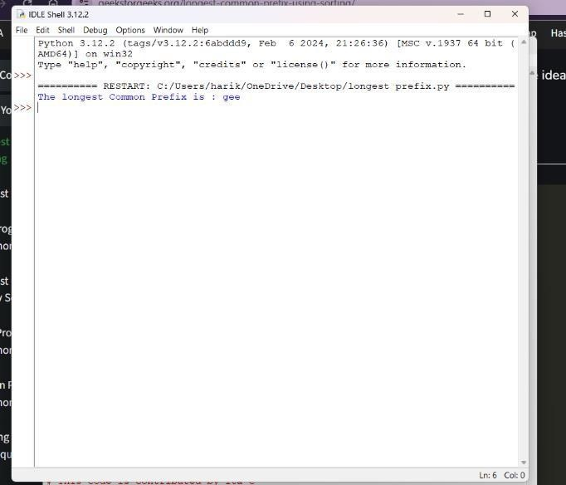

**15. 3Sum**

**Given an integer array nums, return all the triplets [nums[i], nums[j], nums[k]] such that i != j, i**

**!= k, and j != k, and nums[i] + nums[j] + nums[k] == 0. Notice that the solution set must not contain duplicate triplets.**

**Example 1:**

**Input: nums = [-1,0,1,2,-1,-4]**

**Output: [[-1,-1,2],[-1,0,1]] Explanation:**

**nums[0] + nums[1] + nums[2] = (-1) + 0 + 1 = 0. nums[1] + nums[2] + nums[4] = 0 + 1 + (-1) = 0. nums[0] + nums[3] + nums[4] = (-1) + 2 + (-1) = 0.**

**The distinct triplets are [-1,0,1] and [-1,-1,2].**

**Notice that the order of the output and the order of the triplets does not matter.**

**CODE:** def findTriplets(nums, n, Sum):

i = 0 j = 0 k = 0

# list to store all unique triplets. triplet = []

# list to store already found triplets # to avoid duplication.

uniqTriplets = [] # Variable used to hold triplet # converted to string form. temp = "" # Variable used to store current # triplet which is stored in vector # if it is unique. newTriplet = [0, 0, 0] # Sort the input array. nums.sort()

# Iterate over the array from the

# start and consider it as the

# first element. for i in range(n - 2): # index of the first element in # the remaining elements.

j = i + 1 # index of the last element. k = n - 1

while(j < k):

# If sum of triplet is equal to

# given value, then check if

# this triplet is unique or not.

# To check uniqueness, convert

# triplet to string form and

# then check if this string is

# present in set or not. If # triplet is unique, then store # it in list. if(nums[i] + nums[j] + nums[k] == Sum):

temp = str(nums[i]) + ":" + str(nums[j]) + ":" + str(nums[k]) if temp not in uniqTriplets: uniqTriplets.append(temp) newTriplet[0] = nums[i] newTriplet[1] = nums[j] newTriplet[2] = nums[k] triplet.append(newTriplet) newTriplet = [0, 0, 0]

# Increment the first index

# and decrement the last

# index of remaining elements.

j += 1 k -= 1

# If sum is greater than given

# value then to reduce sum

# decrement the last index.

elif(nums[i] + nums[j] + nums[k] > Sum): k -= 1

# If sum is less than given value

# then to increase sum increment

# the first index of remaining # elements. else: j += 1

# If no unique triplet is found, then # return 0. if(len(triplet) == 0): return 0

# Print all unique triplets stored in # list.

for i in range(len(triplet)): print(triplet[i], end = ", ") return 1

# Driver Code nums = [12, 3, 6, 1, 6, 9] n = len(nums) Sum = 24

# Function call if(not findTriplets(nums, n, Sum)): print("No triplets can be formed.") output:

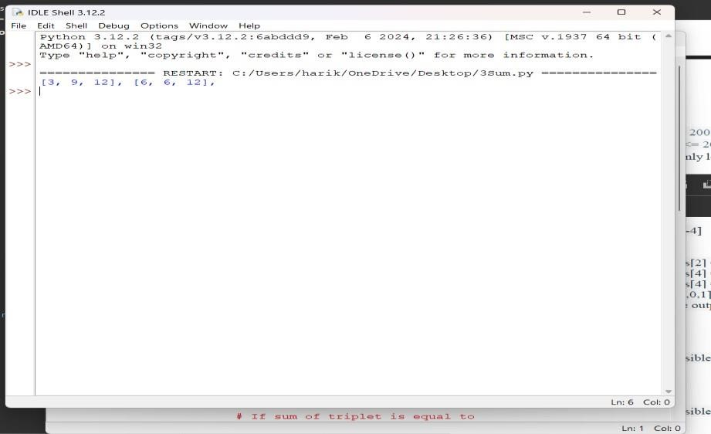

# 16. 3Sum Closest

**Given an integer array nums of length n and an integer target, find three integers in nums such that the sum is closest to target.**

**Return *the sum of the three integers*.**

**You may assume that each input would have exactly one solution.**

**CODE:**

import sys

# Function to return the sum of a # triplet which is closest to x def solution(arr, x):

# To store the closest sum closestSum = sys.maxsize

# Run three nested loops each loop # for each element of triplet for i in range (len(arr)) :

for j in range(i + 1, len(arr)): for k in range(j + 1, len( arr)):

# Update the closestSum

if(abs(x - closestSum) > abs(x - (arr[i] + arr[j] + arr[k]))): closestSum = (arr[i] + arr[j] + arr[k])

# Return the closest sum found return closestSum

# Driver code

if name == " main ":

arr = [ -1, 2, 1, -4 ] x = 1

print(solution(arr, x)) **output:**

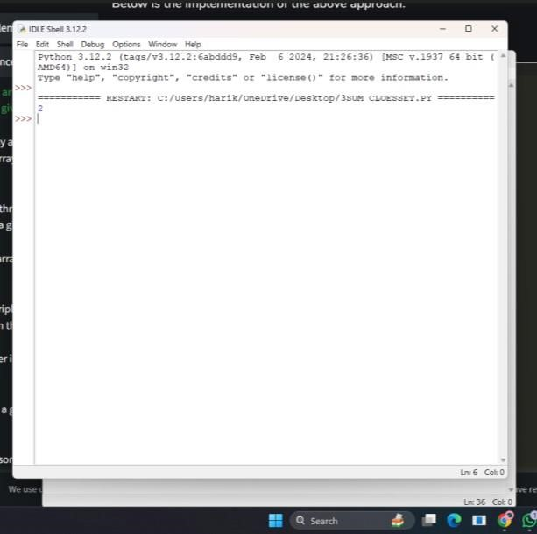

# 17. Letter Combinations of a Phone Number

**Given a string containing digits from 2-9 inclusive, return all possible letter combinations that the number could represent. Return the answer in any order.**

**A mapping of digits to letters (just like on the telephone buttons) is given below. Note that 1**

**does not map to any letters.**

CODE:

# Python3 implementation of the approach from collections import deque

# Function to return a list that contains # all the generated letter combinations

def letterCombinationsUtil(number, n, table):

list = [] q = deque()

q.append("")

while len(q) != 0:

s = q.pop()

# If complete word is generated

# push it in the list if len(s) == n:

list.append(s)

else:

# Try all possible letters for current digit

# in number[] for letter in table[number[len(s)]]:

q.append(s + letter)

# Return the generated list return list

# Function that creates the mapping and # calls letterCombinationsUtil def letterCombinations(number, n):

# table[i] stores all characters that # corresponds to ith digit in phone table = ["0", "1", "abc", "def", "ghi", "jkl",

"mno", "pqrs", "tuv", "wxyz"]

list = letterCombinationsUtil(number, n, table)

s = "" for word in list: s += word + " "

print(s) return

# Driver code number = [2, 3] n = len(number)

# Function call letterCombinations(number, n)

OUTPUT:

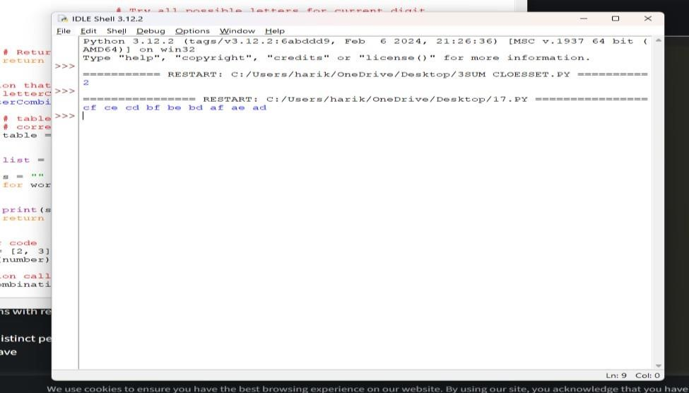

# 18. 4Sum

**Given an array nums of n integers, return *an array of all the unique quadruplets***

**[nums[a], nums[b], nums[c], nums[d]] such that:** ● **0 <= a, b, c, d < n**

* **a, b, c, and d are distinct.**
* **nums[a] + nums[b] + nums[c] + nums[d] == target**

**CODE:**

**# Store the pair of indices class Pair:**

**def init (self, x, y):**

**self.index1 = x self.index2 = y**

**# Function to find the all the unique quadruplets # with the elements at different indices def GetQuadruplets(nums, target):**

**# Store the sum mapped to a list of pair indices map = {}**

**# Generate all possible pairs for the map for i in range(len(nums) - 1):**

**for j in range(i + 1, len(nums)): # Find the sum of pairs of elements sum = nums[i] + nums[j]**

**# If the sum doesn't exist then update with the new pairs if sum not in map:**

**map[sum] = [Pair(i, j)]**

**# Otherwise, add the new pair of indices to the current sum else: map[sum].append(Pair(i, j))**

**# Store all the Quadruplets ans = set()**

**for i in range(len(nums) - 1): for j in range(i + 1, len(nums)): lookUp = target - (nums[i] + nums[j])**

**# If the sum with value (K - sum) exists if lookUp in map:**

**# Get the pair of indices of sum temp = map[lookUp]**

**for pair in temp:**

**# Check if i, j, k and l are distinct or not if pair.index1 != i and pair.index1 != j and pair.index2 != i and pair.index2 != j: l1 = [nums[pair.index1], nums[pair.index2], nums[i], nums[j]]**

**# Sort the list to avoid duplicacy l1.sort()**

**# Update the set**

**ans.add(tuple(l1))**

**# Print all the Quadruplets print(*reversed(list(ans)), sep = '\n')**

**# Driver Code**

**arr = [1, 0, -1, 0, -2, 2]**

**K = 0**

**GetQuadruplets(arr, K)**

**OUTPUT:**

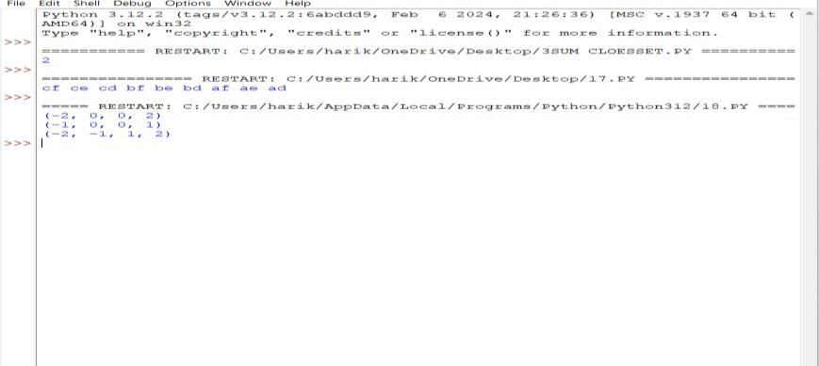

**19. Remove Nth Node From End of List**

**Given the head of a linked list, remove the nth node from the end of the list and return its head.**

**CODE:**

# Python code for the deleting a node from end

# in two traversal

class Node:

def init (self, value):

self.data = value self.next = None def length(head): temp = head count = 0 while(temp != None): count += 1 temp = temp.next return count

def printList(head): ptr = head while(ptr != None): print (ptr.data, end =" ") ptr = ptr.next print()

def deleteNthNodeFromEnd(head, n): Length = length(head) nodeFromBeginning = Length - n + 1 prev = None temp = head for i in range(1, nodeFromBeginning):

prev = temp temp = temp.next if(prev == None): head = head.next return head else: prev.next = prev.next.next return head

if name == ' main ':

head = Node(1) head.next = Node(2) head.next.next = Node(3) head.next.next.next = Node(4) head.next.next.next.next = Node(5) print("Linked List before Deletion:") printList(head)

head = deleteNthNodeFromEnd(head, 4)

print("Linked List after Deletion:") printList(head)

OUTPUT:

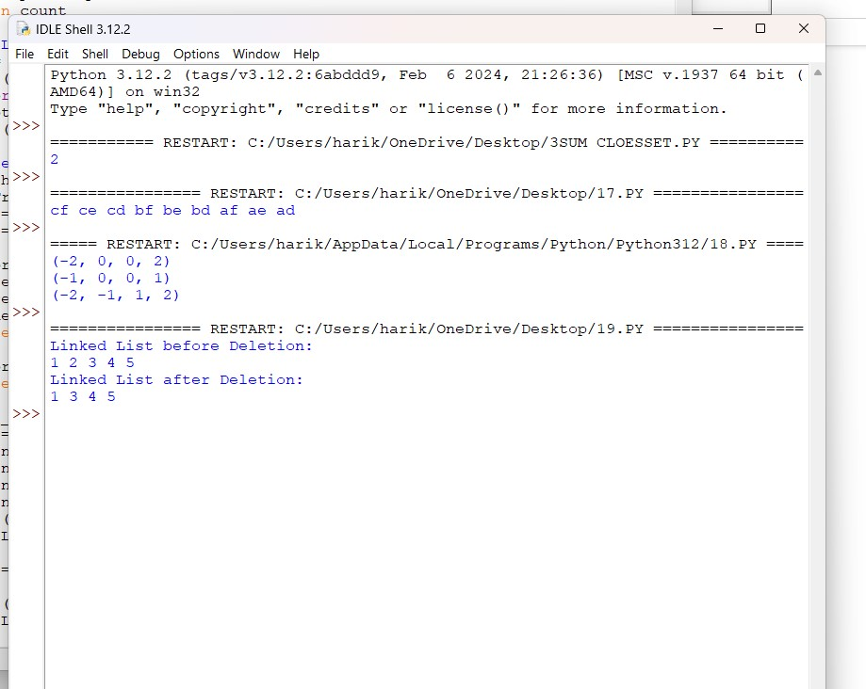

# 20. Valid Parentheses

**Given a string s containing just the characters '(', ')', '{', '}', '[' and ']', determine if the input string is valid.**

**An input string is valid if:**

1. **Open brackets must be closed by the same type of brackets.**
2. **Open brackets must be closed in the correct order.**
3. **Every close bracket has a corresponding open bracket of the same type.**

CODE: def areBracketsBalanced(expr): stack = []

# Traversing the Expression for char in expr:

if char in ["(", "{", "["]: # Push the element in the stack stack.append(char) else:

# IF current character is not opening # bracket, then it must be closing. # So stack cannot be empty at this point. if not stack:

return False current_char = stack.pop() if current_char == '(':

if char != ")": return False if current_char == '{':

if char != "}": return False if current_char == '[':

if char != "]": return False # Check Empty Stack if stack: return False return True

# Driver Code

if name == " main ":

expr = "{()}[]"

# Function call if areBracketsBalanced(expr): print("Balanced") else: print("Not Balanced")

OUTPUT:

